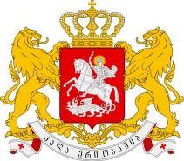
GEORGIA

Statement by Mr. Temuri Pipia,
First Secretary of the Permanent Mission
The 27th Session of the UPR Working Group
UPR of Indonesia

Geneva, 3 May 2017

We welcome the Delegation of Indonesia and thank the Head of Delegation for the presentation of the national report.

Georgia welcomes the ratification of Optional Protocol to the CRC on the involvement of children in armed conflict and Optional Protocol to the Convention on the Rights of the Child, on the sale of children, child prostitution and child pornography, since the last UPR.

We highlight importance of the steps taken to improve national justice system for minors by enacting the new law on Juvenile Justice System and note with appreciation that since the adoption of the Law, there has been a significant reduction in the number of juveniles imprisoned.

Georgia would like to recommend to the Government of Indonesia:

- Consider the ratification of the OP-CAT;
- Speed up the adoption of the draft law on Gender Equality and Justice.

We wish the Delegation of Indonesia a successful UPR.

